Reporting Dashboard Updates 9/3/2026

- General
  - SampDate and AnalDate were reformatted.
- LCR updates
  - In the previous versions of the app, LCR either wasn’t present or when it was present was causing DBPs to fail. LCR data pulls are now functional and DBPs are not crashing.
- DBP updates
  - Scientific notation updated.
- Nitrite/Nitrate updates
  - Merged into one query.
- Updates to the Summary Table
  - 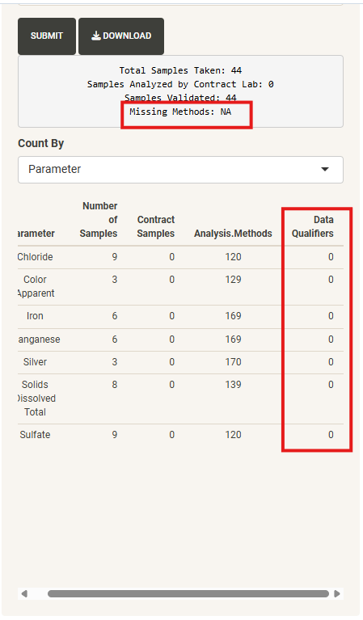
  - Added “Missing Methods” which should populate whenever there is a Method entered in LIMS that does not register in the app.
    - Note: the tables and csv exports will not include unrecognized methods. When the “Missing Methods” section populates, we should manually pull the data and see if it should be reported or not.
      - May have to update the app to include the missing method.
  - Added a “Data Qualifiers” column showing a count of results with data qualifiers. This column is to just be used as an additional check.
    - Note:
      - Results with data qualifiers will not necessarily be filtered out of the table or csv exports. There are instances when having the data qualifier column populated does not invalidate or keep us from reporting the sample.
      - Changed when the tables filter out missing results. In previous deployments, NA/missing results were filtered out in the initial query. To get the data qualifier count, I had to include NA results in the initial query and filter them out when the table is generated/csv downloaded. Table and csv should not contain missing/NA results.

